Peiyu Noah Tian
PHYS 401: Ham Radio
Prof P. Reiff
13 April 2009
The Expansive Uses of Ham Radio
The uses of Amateur Radio are broad and wide-ranging. Amateur Radio, also known as Ham Radio, has contributed significantly to the fields of science, engineering, industry and social services. Primarily, the uses of Ham Radio are two-fold: firstly and more importantly, Ham Radio is used in times of emergency; and secondly, Ham Radio is a hobby to many.
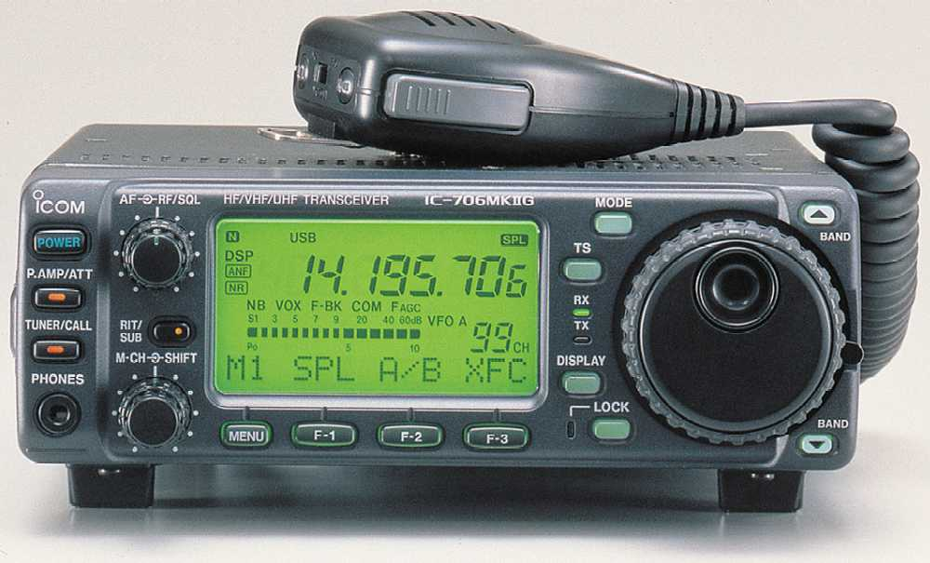
According to the American Radio Relay League (ARRL), Ham Radio operators are known as “Hams.” To speak on any frequency, one must be licensed and registered with the FCC. There are three levels of Ham radio operators: technician, general, and extra. Authorized frequency use depends on the level of operation; however, all levels of Ham radio operators are authorized to communicate on any band during times of emergency. Most recently, Ham Radio operators were involved in assisting residents in areas that were hit hardest by Hurricane Katrina.
“When disaster strikes, ham networks spring into action; The Amateur Radio Emergency Service (ARES) consists of licensed amateurs who have voluntarily registered their qualifications and equipment for communications duty in the public service.”³ Ham Radio operators are integral during times of emergency; without their services, emergency services would be much slower and less efficient. Ham Radio is not only used in specific national emergencies, but it is also used daily by Emergency Medical Technicians in ambulances and other local emergency technicians.
Besides being used in emergency, Ham Radio is also utilized by approximately six million people worldwide. Many of these people use the radio as hobbies, while others use it purely as communication devices, like truck drivers. Accordingly, Ham Radio may be used in many ways; however, it is prohibited to be utilized to conduct business. In sum, the uses of Ham Radio are vast, as it provides both a service and entertainment.

"Amateur Radio." Wikipedia, The Free Encyclopedia. 12 April 2009, 10:55 UTC. Wikimedia Foundation, Inc. 10 Aug. 2004. <http://en.wikipedia.org/wiki/Amateur_radio>.
Lau, Mary E. "Ham Radio Frequently Asked Questions." 12 April 2009, 11:20 UTC. ARRL. 23 May 2006. <http://www.arrl.org/FandES/ead/hamfaq.html>
Krakow, Gary. “Ham Radio Operators to the Rescue After Katrina.” 12 April 2009, 11:25 UTC. MSNBC. 6 September 2005. <http://www.msnbc.msn.com/id/9228945/>

